Homework 2 (15 pts)
- [4 pts]: Consider the following recurrence: T(n) = 2T(n/2) + n/lg n. Draw the first three levels of the recursion tree for this, in the format shown in the Appendix at the end of this assignment.
Solution:
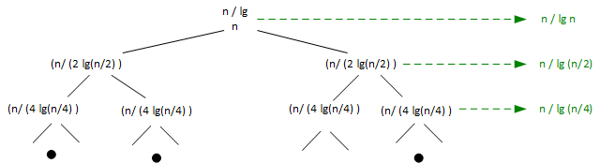

- [4 pts]: Use substitution to prove that the running time of T(n) = 2T(n/2) + n/lg n for n ≥ 2, with base case T(1) = 1, is Ω(n). (It’s not Θ(n), by the way.)
Solution:
We want to proem that T(n) ≥ cn for an appropriate choice of constant c > 0. Assume that the bound hold for n/2 (ignoring floors and ceilings). Then T(n) = 2T(n/2) + n/lg n ≥ cn + n / lg n, and this is ≥ n for any c ≥ 1. So T(n) is Ω( n ).
- [4 pts] Solve each of the following four recurrence equations using the Master Method, or indicate it can’t be solved that way. Do this by filling out the tables as I did in the example for case 3 (note that you don’t need to fill out the “if case 3” columns unless it’s case 3, and if the Master Method doesn’t apply, just say “NA”, I’ll assume you know that it’s because f(n) isn’t polynomially larger or smaller than 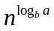).
Example: T(n) = T(n/2) + n
a = | b = | 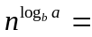 | F(n) = | Case  (1,2,3, NA) | If case 3,  c = | If case 3  n₀ = | T(n) = complexity
1 | 2 | n⁰ | n¹ | 3 | 3/4 | 1 | Θ(n)

- T(n) = 3T(n/2) + n
a = | b = |  | F(n) = | Case  (1,2,3, NA) | If case 3,  c = | If case 3  n₀ = | T(n) = complexity
3 | 2 | n^{lg 3} | n | 1 | NA | NA | Θ(n^{lg 3})

- T(n) = 2T(n/2) + n (1 + sin n)
a = | b = |  | F(n) = | Case  (1,2,3, NA) | If case 3,  c = | If case 3  n₀ = | T(n) = complexity
2 | 2 | n | N(1+ sin n) | NA | NA | NA | NA

- T(n) = T(n/2) + n³
a = | b = |  | F(n) = | Case  (1,2,3, NA) | If case 3,  c = | If case 3  n₀ = | T(n) = complexity
1 | 2 | n⁰=1 | n³ | 3 | 2/3 | 2 | Θ(n³)
Really, any c in ½ < c < 1 with n₀ > 1.
- T(n) = 4T(n/2) + n²
a = | b = |  | F(n) = | Case  (1,2,3, NA) | If case 3,  c = | If case 3  n₀ = | T(n) = complexity
4 | 2 | n² | n² | 2 | NA | NA | Θ(n² lg n)

- [4 pts] Consider the following pseudocode. It implements binary search except instead of probing in the middle of an array, it probes ¼ of the way into the array. For an upper bound to the running time, assume you would always miss low and each successive iteration would be run on an array ¾ the size of the present array. Write the recurrence that specifies this upper bound, and use the Master method to give an upper bound to the asymptotic running time.

int f( int[n] a, int k ) {

if ( n == 1 ) {
return 0;
}
else if ( a[floor(n/4)] < k ) {
b = array of a[floor(n/4) + 1],...,a[n]; // Constant time work
return f( b, k );
}
else if ( a[floor(n/4)] = k ) {
return n/4;
}
else {
b = array of a[0],...,a[floor(n/4)-1]; // Constant time work
return f( b, k );
}

Solution:

So if you know this is like binary search but you’re always going to go into the larger section of the array, the recurrence for the worst case is T(n) = T(3n/4) + 1.
Here a = 1, b = 4/3, f(n) = 1. n^(log _{4/3} 1) = n⁰ = 1, since the log of 1 to any base > 1 is zero.
So n^(log_{b}a) = 1 = f(n), so case 2 of the Master Method applies and T(n) = O(log n).

Note that by the same reasoning, the lower bound would be T(n) = Ω(log n), so even if you do binary search by splitting up the array asymmetrically, it’s still a Θ(lg n) operation.
APPENDIX: How I want the recursion tree for question 1 to look, by example.
Let’s suppose that I had given you the recursion T(n) = 2T(n/2) + n². I would want you to draw the following, with the total amount of work done at that level on the right:
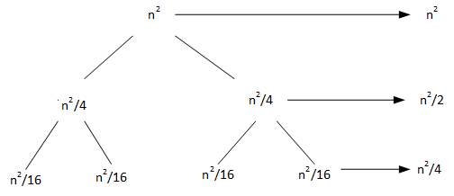

Note that 16 points are possible, so basically this homework includes a little extra credit.
Note that the values of c and n₀ are not unique, anything so that af(n/b) ≤ cf(n) for all n ≥ n₀ is correct.

